Word to PDF conversion

Lorem ipsum dolor sit amet, lacus amet amet ultricies. Quisque mi venenatis morbi libero, orci dis, mi ut et class porta, massa ligula magna enim, aliquam orci vestibulum

thematical Equation
$$f\left(x\right)=a_{0}+\sum_{n=1}^{∞}{\left(a_{n}\cos{\frac{nπx}{L}}+b_{n}\sin{\frac{nπx}{L}}\right)}$$

Turpis facilisis vitae consequat, cum a a, turpis dui consequat massa in dolor per, felis non amet.
Auctor eleifend in omnis elit vestibulum, donec non elementum tellus est mauris, id aliquam, at lacus, arcu pretium proin lacus dolor et. Eu tortor, vel ultrices amet dignissim mauris vehicula.
Lorem tortor neque, purus taciti quis id. Elementum integer orci accumsan minim phasellus vel.

SVG Image of Company Structure

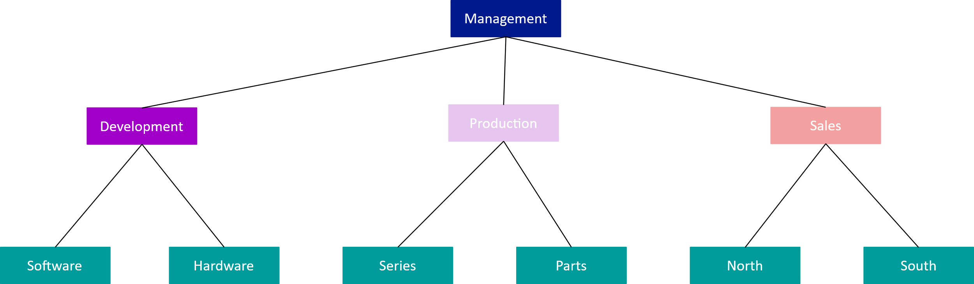

Northwind Suppliers
ID | Company Name | Contact Name | Address | City | Country
1 | Exotic Liquids | Charlotte Cooper | 49 Gilbert St. | London | UK
2 | New Orleans Cajun Delights | Shelley Burke | P.O. Box 78934 | New Orleans | USA
3 | Grandma Kelly's Homestead | Regina Murphy | 707 Oxford Rd. | Ann Arbor | USA
4 | Tokyo Traders | Yoshi Nagase | 9-8 Sekimai Musashino-shi | Tokyo | Japan
5 | Cooperativa de Quesos 'Las Cabras' | Antonio del Valle Saavedra | Calle del Rosal 4 | Oviedo | Spain
6 | Mayumi's | Mayumi Ohno | 92 Setsuko Chuo-ku | Osaka | Japan
7 | Pavlova, Ltd. | Ian Devling | 74 Rose St. Moonie Ponds | Melbourne | Australia
8 | Specialty Biscuits, Ltd. | Peter Wilson | 29 King's Way | Manchester | UK
9 | PB Knäckebröd AB | Lars Peterson | Kaloadagatan 13 | Göteborg | Sweden
10 | Refrescos Americanas LTDA | Carlos Diaz | Av. das Americanas 12.890 | São Paulo | Brazil
11 | Heli Süßwaren GmbH & Co. KG | Petra Winkler | Tiergartenstraße 5 | Berlin | Germany
12 | Plutzer Lebensmittelgroßmärkte AG | Martin Bein | Bogenallee 51 | Frankfurt | Germany
13 | Nord-Ost-Fisch Handelsgesellschaft mbH | Sven Petersen | Frahmredder 112a | Cuxhaven | Germany
14 | Formaggi Fortini s.r.l. | Elio Rossi | Viale Dante, 75 | Ravenna | Italy
15 | Norske Meierier | Beate Vileid | Hatlevegen 5 | Sandvika | Norway
16 | Bigfoot Breweries | Cheryl Saylor | 3400 - 8th Avenue Suite 210 | Bend | USA
17 | Svensk Sjöföda AB | Michael Björn | Brovallavägen 231 | Stockholm | Sweden
18 | Aux joyeux ecclésiastiques | Guylène Nodier | 203, Rue des Francs-Bourgeois | Paris | France
19 | New England Seafood Cannery | Robb Merchant | Order Processing Dept.  2100 Paul Revere Blvd. | Boston | USA

REGISTRATION FORM

Please read all instructions carefully before filling out the form.
PERSONAL INFORMATION
Andrew Fuller
Name :
908 W. Capital Way

Address 1 :
WA, USA.

Address 2 :
andrew@gmail.com
Email :
+122-2222222

Phone :
APPROVAL WORKFLOW
Administrative review
Final approval
Document submission

REQUIRED DOCUMENTS
- Proof of Identity
- Proof of Address
- Passport Size Photo

The Northwind sample database (Northwind.mdb) is included with all versions of Access. It provides data you can experiment with and database objects that demonstrate features you might want to implement in your own databases. Using Northwind, you can become familiar with how a relational database is structured and how the database objects work together to help you enter, store, manipulate, and print your data.

Software Development Life Cycle
Requirement Analysis
1
Design
2
Development
3
Testing
4
Maintenance
5

CHEST X-RAY REPORT (Vietnamese Translation)
Tên bệnh nhân: Minh Tuán
Ngày sinh : 01/01/1980
Ngày thực hiện: 05/12/2023
Số X-quang : 52587412
Hình 1: Ảnh X-quang ngực – Phiên bản TIFF

KẾT QUẢ ĐỌC PHIM:
- Phổi: Trong và căng tốt; không có dấu hiệu viêm phổi, tràn khí màng phổi hoặc tràn dịch.
- Tim: Kích thước và hình dạng bình thường; bóng tim trong giới hạn bình thường; không có tim to hoặc tràn dịch màng tim.
- Cơ hoành: Rõ ràng và đều; không có hiện tượng nâng cao hoặc hạ thấp.
- Xương: Hình dạng bình thường; không có gãy xương hoặc trật khớp.
- Mô mềm: Hình dạng bình thường ở vùng ngực.
KHUYẾN NGHỊ:
Hiện tại không cần đánh giá thêm.
GHI CHÚ BỔ SUNG:
Không có.

